Cora Proctor Quimby celebrates her 106th Birthday on March 4, 2015
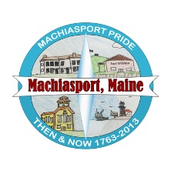

O
n February 28th at 1:30 pm Cora Quimby’s family will gather at the Marshall Health Care Facility in Machias, Maine to celebrate Cora’s 106th Birthday.
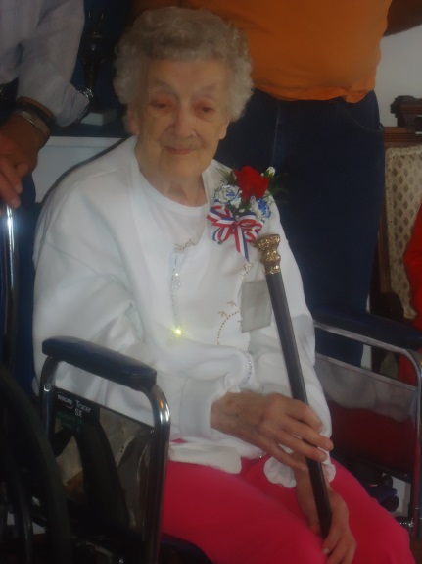

Cora Proctor Quimby was born on March 4, 1909 in the Larrabee District of Machiasport. Her parents were James Everett & Mary Emma Proctor. According to Cora’s birth certificate, her parents had eleven girls-no boys. As a young girl she worked at the Indian Cove factory in Bucks Harbor where she would walk with her sister across the field to go to work.

Cora married Norman Quimby on May 30, 1932 and they were married 48 years before he passed away on August 11, 1980. She has live more than a century and during this time she has witnessed more changes than many of us ever will, including advances such as the automobile, aircraft, television, computer and in the field of medicine. Imagine witnessing 22 out of 42 Presidential Elections.

Cora remains Machiasport’s oldest citizen. In 2013, during the Town’s 250th Celebration, she was presented with the town’s Boston Post Cane and further honored when the town dedicated the Annual Town Meeting Report to her.

When a person lives to or beyond the age of 100 years we call them a Centenarian. One hundred years ago when Cora was a child, children had to work to help out their family. They cooked did the laundry and helped feed and care for the farm animals, while the older children would help care for the younger children. Usually, the children attended school, but only until they were old enough to go to work. By the time they became teenagers they were expected to help support the family. A century ago we were in the midst of industrialization and the rules about child labor were quite different from today.

On Cora’s 100th Birthday, five generations from her family came together to help her celebrate her new title- The Centenarian.
Happy 106th Birthday, sweet Cora!
1st GENERATION:
Cora Proctor Quimby
and
Norman Quimby

2nd GENERATION: 3 Children

Betty Florence Quimby
Deceased March 22, 2013
Faunce Oswald Quimby Deceased March 3, 2004
Daniel Nelson Quimby

3rd GENERATION: 12 Grand children
Norman Wood, Karen Mahar, Lois DeCatur , Clarice Colbeth, Stacey Smith, Patsy Gagne, Wanda Wood, Paul Quimby, Janet Lea Robertson, Kelly Quimby, Mary Quimby, and Tracy Quimby

4th GENERATION: 31 Great, Grand Children

Troy Wood, Janelle McClure, Shawn Wood , Michael Murphy, Amanda Boynton, Dale Renshaw, Stephen DeCatur, David DeCatur , Evan Colbeth, Cody Colbeth, Michael Beal, Katie Gagne, Ashley Douglas, Abby Gagne, John Polley Jr., Trevor Harmon, Quincy Davis, Brady Davis, Calvin Davis, Krow Quimby, Faunce Quimby, Carol Ann Robertson, Tabatha Robertson, Dalton Scoville, William McDonald, Daniel McDonald, Krystle Getchell, Gina Quimby, Samantha Rodriguez , Caera Ryan and Alivia Ryan

5th GENERATION: 20 Great, Great Grand Children Judson Wood, Gavin Wood, Scarlett Wood, Machaela McClure, Alicia McClure, Alexander McClure, Emily McClure, Ryan Murphy, Carter Murphy, Justin Farnsworth, Isaiah Boynton, Cameron Boynton, Serena Boynton, Christian Boynton, Destinee DeCatur, Nathaniel Polley, Kyndrah Dias, Colin Hallowell, Carson Getchell, and Kaiden Jones

